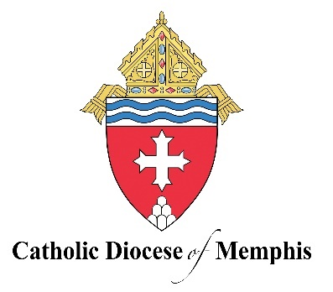
Strategic Pastoral Plan
Living the Anointed Life
2025-2027

Our Vision
To live a Christ-centered fellowship of love, on fire with the love of God and neighbor, to see individuals, families, parishes, and our schools working together to build up the Kingdom of God in West Tennessee.

Our Mission
Living the anointed life in Word and Sacrament.

Our Priorities
Evangelization: Born of a Eucharistic Life, we will proclaim the Good News to all in every part of West Tennessee.

- Year 1: Strengthen the understanding of missionary discipleship of our Risen Lord, and how this speaks to evangelization in our families, schools, and parishes.
- Year 2: Create and implement programs that integrate evangelization into the life of our parishes and schools.
- Year 3: Invite and accompany neighbors to join our community of faith.

- Scripture: Matthew 28:19-20; Mark 1:35-38; Luke 4:42-44
- Catechism of the Catholic Church: 863, 864, 865

Scripture
“Go, therefore, and make disciples of all nations, baptizing them in the name of the Father, and of the Son, and of the holy Spirit, teaching them to observe all that I have commanded you. And behold, I am with you always, until the end of the age” (Matthew 28:19-20).

“Rising very early before dawn, he left and went off to a deserted place, where he prayed. Simon and those who were with him pursued him and on finding him said, ‘Everyone is looking for you.’ He told them, “Let us go on to the nearby villages that I may preach there also. For this purpose, have I come” (Mark 1:35-38).

“At daybreak, Jesus left and went to a deserted place. The crowds went looking for him, and when they came to him, they tried to prevent him from leaving them. But he said to them, ‘To the other towns also I must proclaim the good news of the kingdom of God, because for this purpose I have been sent.’ And he was preaching in the synagogues of Judea” (Luke 4:42-44).

Catechism of the Catholic Church
The whole Church is apostolic, in that she remains, through the successors of St. Peter and the other apostles, in communion of faith and life with her origin: and in that she is ‘sent out’ into the whole world. All members of the Church share in this mission, though in various ways. ‘The Christian vocation is, of its nature, a vocation to the apostolate as well.’ Indeed, we call an apostolate ‘every activity of the Mystical Body" that aims "to spread the Kingdom of Christ over all the earth.’ ‘Christ, sent by the Father, is the source of the Church's whole apostolate’; thus the fruitfulness of apostolate for ordained ministers as well as for lay people clearly depends on their vital union with Christ. In keeping with their vocations, the demands of the times and the various gifts of the Holy Spirit, the apostolate assumes the most varied forms. But charity, drawn from the Eucharist above all, is always ‘as it were, the soul of the whole apostolate.’ The Church is ultimately one, holy, catholic, and apostolic in her deepest and ultimate identity, because it is in her that ‘the Kingdom of heaven,’ the ‘Reign of God,’ already exists and will be fulfilled at the end of time. the kingdom has come in the person of Christ and grows mysteriously in the hearts of those incorporated into him, until its full eschatological manifestation. Then all those he has redeemed and made ‘holy and blameless before him in love,’ will be gathered together as the one People of God, the ‘Bride of the Lamb,’ ‘the holy city Jerusalem coming down out of heaven from God, having the glory of God.’ For ‘the wall of the city had twelve foundations, and on them the twelve names of the twelve apostles of the Lamb’” (CCC 863-865).

