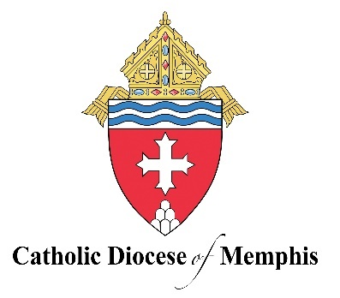
Strategic Pastoral Plan
Living the Anointed Life
2025-2027

Our Vision
To live a Christ-centered fellowship of love, on fire with the love of God and neighbor, to see individuals, families, parishes, and our schools working together to build up the Kingdom of God in West Tennessee.

Our Mission
Living the anointed life in Word and Sacrament.

Our Priorities
Formation: In the fruitfulness of Eucharistic Life, we commit ourselves and our families to lifelong formation in the apostolic traditions of our faith.

- Year 1: Create weekly opportunities for on-going faith formation of adults, teens, and children in our 46 parishes and 13 Catholic schools.
- Year 2: Provide formation for parish and school leaders on best practices of evangelization that create pathways for missionary discipleship.
- Year 3: Implement these newly found pathways of formation within missionary discipleship as integral to parish and school life.

- Scripture: John 1:18; John 14:6; John 15:5
- Catechism of the Catholic Church: 1785, 2685, 2221

Scripture
“No one has ever seen God. The only Son, God, - who is at the Father’s side, has revealed him” (John 1:18).

“Jesus said to him, ‘I am the way and the truth and the life. No one comes to the Father except through me’” (John 14:6).

“I am the vine, you are the branches. Whoever remains in me and I in him will bear much fruit, because without me you can do nothing” (John 15:5).

Catechism of the Catholic Church:
“In the formation of conscience the Word of God is the light for our path, we must assimilate it in faith and prayer and put it into practice. We must also examine our conscience before the Lord's Cross. We are assisted by the gifts of the Holy Spirit, aided by the witness or advice of others and guided by the authoritative teaching of the Church” (CCC 1785).

The Christian family is the first place of education in prayer. Based on the sacrament of marriage, the family is the ‘domestic church’ where God's children learn to pray ‘as the Church’ and to persevere in prayer. For young children in particular, daily family prayer is the first witness of the Church's living memory as awakened patiently by the Holy Spirit” (CCC 2685).

The fecundity of conjugal love cannot be reduced solely to the procreation of children, but must extend to their moral education and their spiritual formation. ‘The role of parents in education is of such importance that it is almost impossible to provide an adequate substitute.’ The right and the duty of parents to educate their children are primordial and inalienable” (CCC 2221).

