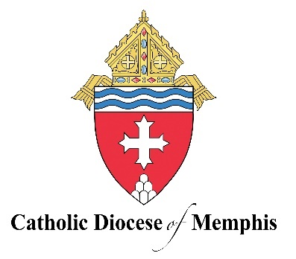
Strategic Pastoral Plan
Living the Anointed Life
2025-2027

Our Vision
To live a Christ-centered fellowship of love, on fire with the love of God and neighbor, to see individuals, families, parishes, and our schools working together to build up the Kingdom of God in West Tennessee.

Our Mission
Living the anointed life in Word and Sacrament.

Our Priorities
Stewardship: We manifest the Eucharistic Life through our generous and intentional stewardship of all God’s gifts.

- Year 1: Develop a “spirituality of stewardship” within families and parish organizations.
- Year 2: Form parish-level leadership to embody the call to a “spirituality of stewardship” in the use of our time, the talents we are given, and the treasure we offer.
- Year 3: Magnify the fruitfulness of a “spirituality of stewardship,” recognizing God’s abundant generosity in both family and parish life.

- Scripture: Luke 9:12-17; Luke 21:1-4; 1 Peter 4:10; John 10:10
- Catechism of the Catholic Church: 1832

Scripture:
As the day was drawing to a close, the Twelve approached him and said, ‘Dismiss the crowd so that they can go to the surrounding villages and farms and find lodging and provisions; for we are in a deserted place here.’ He said to them, ‘Give them some food yourselves.’ They replied, ‘Five loaves and two fish are all we have, unless we ourselves go and buy food for all these people.’ Now the men there numbered about five thousand. Then he said to his disciples, ‘Have them sit down in groups of [about] fifty.’ They did so and made them all sit down. Then taking the five loaves and the two fish, and looking up to heaven, he said the blessing over them, broke them, and gave them to the disciples to set before the crowd. They all ate and were satisfied. And when the leftover fragments were picked up, they filled twelve wicker baskets” (Luke 9:12-17).

When he looked up he saw some wealthy people putting their offerings into the treasury and he noticed a poor widow putting in two small coins. He said, ‘I tell you truly, this poor widow put in more than all the rest; for those others have all made offerings from their surplus wealth, but she, from her poverty, has offered her whole livelihood’” (Luke 21:1-4).

“As each one has received a gift, use it to serve one another as good stewards of God’s varied grace”
(1 Peter 4:10).

Catechism of the Catholic Church:
The fruits of the Spirit are perfections that the Holy Spirit forms in us as the first fruits of eternal glory. the tradition of the Church lists twelve of them: ‘charity, joy, peace, patience, kindness, goodness, generosity, gentleness, faithfulness, modesty, self-control, chastity’” (CCC 1832)

“A thief comes only to steal and slaughter and destroy; I came so that they might have life and have it more abundantly” (John 10:10).

