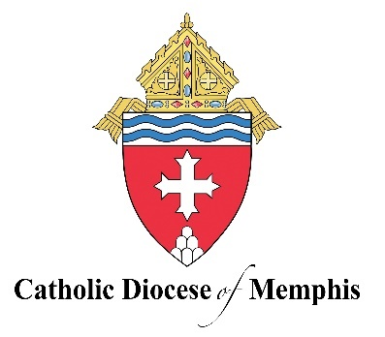
Strategic Pastoral Plan
Living the Anointed Life
2025-2027

Our Vision
To live a Christ-centered fellowship of love, on fire with the love of God and neighbor, to see individuals, families, parishes, and our schools working together to build up the Kingdom of God in West Tennessee.

Our Mission
Living the anointed life in Word and Sacrament.

Our Priorities
Unity: Revealed through our Eucharistic Life, we, though many, are one Body in Christ.

- Year 1: Compare and contrast secular notions of “diversity” with the diversity seen in the Body of Christ.
- Year 2: Implement activities in our parishes and schools that underscore the rich diversity seen in all who are created in the image and likeness of God.
- Year 3: Assess and continually renew our response to Christ’s call for unity.

- Scripture: John 17: 20-23; 1 Corinthians 12-31; 1 John 4:16, 19-21
- Catechism of the Catholic Church: 361

Scripture
“’I pray not only for them, but also for those who will believe in me through their word, so that they may all be one, as you, Father, are in me and I in you, that they also may be in us, that the world may believe that you sent me. And I have given them the glory you gave me, so that they may be one, as we are one, I in them and you in me, that they may be brought to perfection as one, that the world may know that you sent me, and that you loved them even as you loved me’” (John 17: 20-23).

1 Corinthians, The First Letter to the Corinthians | USCCB (1 Corinthians 12-31)

We have come to know and to believe in the love God has for us. God is love, and whoever remains in love remains in God and God in him. We love because he first loved us. If anyone says, ‘I love God,’ but hates his brother, he is a liar; for whoever does not love a brother whom he has seen cannot love God whom he has not seen. This is the commandment we have from him: whoever loves God must also love his brother” (1 John 4:16, 19-21).

Catechism of the Catholic Church
“This law of human solidarity and charity’, without excluding the rich variety of persons, cultures and peoples, assures us that all men are truly brethren” (CCC 361).

