Increased Offertory Program
  - Shining a Light on Growing Generosity



  - [ADD YOUR PARISH NAME HERE]
  - Catholic Diocese of Memphis

“As each one has received a gift, use it to serve one another as good stewards of God’s varied grace.” (1 Peter 4:10)




  - Acknowledgements

Catholic Extension Society adapted this from a successful Increased Offertory Program designed and implemented by the Office of Stewardship and Development for the Diocese of Owensboro. Thank you to Valeria Vessels, Director of Stewardship Ministry, Owensboro, KY, and the Diocese of Owensboro for allowing Catholic Extension Society to share this information with you.



Contents
Spirituality of Giving 4
Introduction to the Increased Offertory Program 5
Overview 6
IOP Completed 8
How to conduct an Increased Offertory Program 9
Committees/Teams 9
Calendar of Activities: 10
Sample Letters 18
First Letter for Week 1 18
Second Letter (with Brochure and Commitment card) 20
Thank Letter You for Returning Card 22
Please Return Commitment Card 23
Petitions for the Prayers of the Faithful 24
Bulletin Inserts 26
God’s Generosity Multiplying Our Gifts 26
How Much Should I Give? 28
Benefits of Online Giving 30
Increased Offertory Brochure 32
Pledge Card 34
Increased Offertory Calling Script 36
Increased Offertory Report Final Report 38
Notes: 39

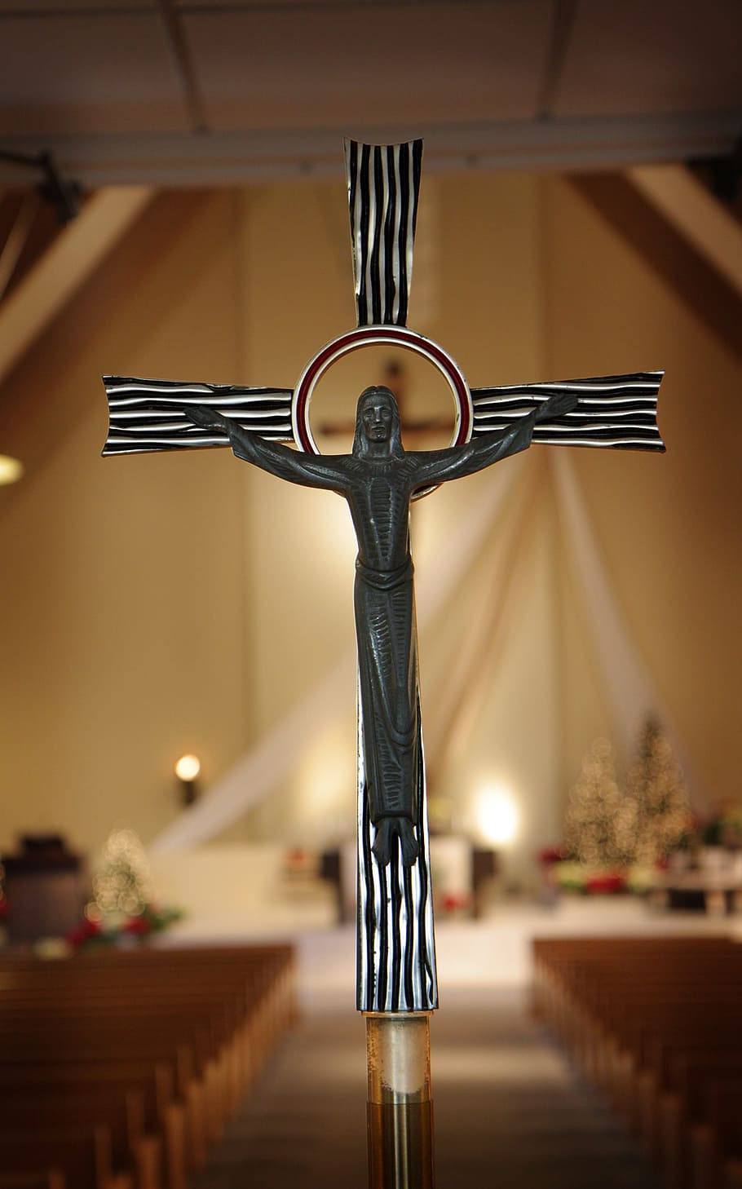
Spirituality of Giving
As Catholics, the spirituality of giving is rooted in our understanding of God as a loving and generous provider who calls us to share in His abundance and care for those in need.

At the heart of this spirituality is the recognition that everything we have comes from God and belongs to Him. Our possessions, time, talents, and resources are not ours to hoard or control, but rather gifts that we are called to use for the greater good of all.

Through giving, we express our gratitude to God for His blessings and acknowledge our interconnectedness with others in the Body of Christ. We recognize that we are called to be stewards, rather than owners, of the gifts that God has entrusted to us, and that our true wealth lies in our relationships with God and with one another.

Offertory happens at every weekend Mass, when we unite our gifts, alongside the bread and wine, with the sacrifice of Christ. It is our opportunity to reflect on the gifts God has given us and to offer them in service to Him and the Church.

Giving, then, becomes not just an act of charity or obligation, but a spiritual practice that draws us closer to God and to one another. It is a way of living out our faith in tangible ways, and of participating in the mission of the Church to bring Christ's love and healing to a hurting world.

Ultimately, the spirituality of giving is grounded in the love of God, who gave His only Son for our salvation. As we give of ourselves, we participate in this divine love and become more fully alive in Christ.

Introduction to the Increased Offertory Program
Strengthening parish offertory will strengthen ministerial resources and by extension will strengthen community outreach and the hearts of parishioners. It is important that our parishioners understand the spiritual as well as practical importance of offertory giving.

Catholic Extension Society knows that flourishing faith communities are those that are steeped in the realities of people and they operate as Pope Francis said, like “field hospitals.” According to Fr. Jack Wall, “they maintain solidarity with their people through the various arcs of life – the moments of sorrow, as well as those of joy and celebrations. These faith communities are not just social service organizations. Nor are they member-centered clubs. Rather they are havens of hope where people find a loving community to celebrate the blessings in their lives, find strength in hard times through prayer and fellowship, and ultimately commissioned to transform the world.” This is especially true in the rural parishes served by this program. These churches are more than places of worship; they are the hearts of their rural communities, and they offer a sense of connection and belonging.

Many rural parishes are financially strained and struggle to meet their monthly bills. They have little left over to support and help those in their parish communities. Parish organizations mature like people. In Maslow's Hierarchy of Needs, a person struggling to meet the basic needs cannot focus on higher-level aspirations, such as self-actualization. Likewise for financially strained parishes, a mature and well-funded parish can focus on achieving their full potential. A financially healthy parish can become the best versions of themselves, focusing on their mission to build community, cultivate beauty and extend mercy to all.

What the Owensboro diocese initially began as a simple Increased Offertory initiative gradually evolved over several years. The program grew as parishes came forward with valuable suggestions for improvement. Fast forward two years, and they had developed a comprehensive nine-week program that continues to evolve. In 2025, Catholic Extension Society adopted and adapted the program to help rural parishes in Mission Dioceses increase their offertory and become vibrant parish communities. In this second year, the pilot program continues to improve as our dioceses adopt and implement the program.

This program is designed to encourage those who are currently giving to review and increase their generosity to the parish. And to encourage those who are not yet giving to the parish to begin participating. It is designed to reinforce the unity between parish mission and financial support. The added benefit is an increase in parish community engagement. We know that giving deepens our parishioners’ sense of stewardship, encouraging a spiritual reflection on the blessings they have received and their responsibility to support the Church’s mission.

For parishes, the Increased Offertory Program is tailored to assist in boosting their weekly collections. Please note, this program does not replace existing stewardship initiatives, nor does it serve as a substitute for a parish capital campaign. Instead, its primary focus is on addressing a parish's annual budgetary needs and highlighting the crucial role of the faithful’s financial support in meeting those on-going needs.

Overview
- Letters to the parishioners
  - The first letter from the pastor introduces the program, explains its purpose and necessity, and briefly reviews the “state of the parish” presentation that was given at a weekend Mass. It emphasizes the significance of generosity and introduces the Lay Witness speakers who share their deep commitment to their church at weekend Masses.
  - The second letter, sent during the third week of the program, is the commitment letter and contains a brochure and commitment card.
  - The thank you letter, signed by the pastor, is sent when a donor returns their commitment cards.
  - The reminder letter, signed by the pastor, is sent to those who have not yet returned their commitment cards.

- Petitions for Prayers of the Faithful
As we embark on this program together, we recognize the importance of spiritual support. Specific petitions for the Prayers of the Faithful during Mass are included to keep our intentions at the forefront. This way, we unite in prayer for the program's success and the well-being of our parishioners.

- Calling Scripts for Volunteers
A dedicated calling committee (see committee list below) plays a vital role in the program's success. To assist these volunteers, we have provided calling scripts that guide them through the call. These scripts not only serve as reminders for parishioners to return their commitment cards but also encourage open communication and the collection of any prayer requests from parishioners. (At least call your larger donors who have not responded.)

- Generosity Guide Brochure
To aid in the discernment of increasing giving, we have included a Generosity Guide Brochure. This resource provides valuable insights and practical tips for those considering their own generous, proportionate, and sacrificial contributions. It is a helpful tool for individuals and families as they contemplate their commitment to the parish.

- Three Bulletin Inserts
Effective and ongoing communication is essential to keeping the program in the forefront of the parishioners’ minds. To streamline this aspect, we have prepared three bulletin inserts that you can customize to suit your parish's distinctive needs. One of these inserts explains electronic giving and its positive impact on the parish and the donor. Whether you choose to edit them or use them as-is, these inserts provide a convenient way to keep parishioners informed and engaged.

- Editable Commitment Card
Recognizing the individuality of each parish, there is an editable Commitment Card included. This flexibility allows you to tailor it to your specific parish requirements. For your parishioner, this card serves as a tangible commitment to support their parish's financial needs.

- Setup of Committees to Help
In giving, individuals are greatly motivated by the actions of others. Knowing that others have given to and support a certain cause, encourages them to do the same.

Furthermore, in small parish communities, no single person, even the pastor, can do it all. Committees provide an opportunity for parishioners to utilize their skills and expertise in their areas of interest. And studies have shown us that people are more likely to give to a cause where they volunteer.

For these reasons, it is important that a program like Increased Offertory creates opportunities for volunteers to share their skills. Sharing God-given abilities is a key component of stewardship.

The committees/teams needed to make this program a success are listed in the “how to” section.

- Follow up
At this stage of the program, we will need a person, a volunteer skilled in using Excel or a parish staff person, to complete a spreadsheet with the information from the returned commitment cards. This work should be done on a regular on-going basis. This person keeps the finance committee informed with an updated report on how the cards are coming in and the increase in offertory. It is important to keep the parish informed of this progress. The pastor and/or finance committee can determine the best way to make this happen.

All these resources should be personalized for your parish.

The Increased Offertory Program demonstrates our diocese’s commitment to provide a comprehensive and adaptable resource for our parishes. Our goal is to foster a sense of unity, purpose, and generosity within our parish communities. Together, we continue to shine a light on increasing generosity, ensuring the strength and sustainability of our beloved parishes.

IOP Completed
Below are examples of the final results for parishes within the Diocese of Owensboro when this program was first implemented.
Parish | First Year Increase | Percentage
St. Joseph & Paul | $219,200 | 33%
Our Lady of Lourdes | $150,900 | 21%
Blessed Sacrament | $38,300
St. Joseph - CC | $30,230 | 29%
St. Peter - Stanley | $17,500 | 25%
St. Mary Franklin | $31,500 | 23%
St. Stephen's Cathedral | $96,712 | 18%
Christ the King - Madisonville | $26,800 | 10%
Sts. Peter & Paul | $73,200 | 10%
Increased Offertory parish increases | $684,342

Imagine the financial impact on these parishes over the next three years as parishioners continue their increased gifts.
$684,342 x 3 years = $2,053,026

During the 1st year of the IOP program in 2025, participating parishes had the following results:

Total % of
Parish Name Increase Increase Participation Rate
Our Lady of Peace, (El Paso) $30,865 14.81% 22% - 320 Families
St Thomas, (El Paso) $20,540 11.34% 8% - 430 Families
St Peter (Davenport) $41,128 42.80% 80% - 145 Families
St Mary (Davenport) $28,623 16.13% 49% - 307 Families
St Mary (Salina) $49,009 20.47% 19% - 357 Families

The participation rate represents the % and number of families who
participated in IOP program.

How to conduct an Increased Offertory Program
The offertory program is conducted over a seven-week period and includes homily presentations by the pastor and selected parish leaders, along with segmented, personalized letters to all registered households in the parish. It concludes with phone call reminders to those who have not yet responded.

The Increased Offertory Program is designed to help a parish increase its weekly collections. This does not replace your stewardship programs. Likewise, the Offertory Program is not usually an acceptable substitute for a parish capital campaign. The Offertory Program focuses on helping a parish meet its budgetary needs and speaks very directly about the financial needs and future goals of the parish.

Committees/Teams
It will be important to recruit active, committed, and passionate parishioners who will make this program successful. Everyone has skills they can share on one of the committees listed below. You will want to be sure the people you recruit are comfortable doing the work of the committee they serve. Each person’s time commitment will vary depending on their committee. However, most work will be done in the fall, September through early November. Not all committees need to be large; in fact, some will function better with just a few members.

The Program has the strongest impact when there are a group of people focused on the activity in each of these areas. In some parishes committees/teams can be combined or the Finance Committee and/or Pastoral Council can take on these assignments. Determine what will work best for your Parish.

- Lay Witness speakers: These are parishioners who share their deep commitment to our Catholic church at the 3rd weekend Masses. They have an important role as peers talking to their peers, explaining why they give and how their gifts, collectively shared with others, provide the funds for the parish to not just survive but thrive. They emphasize the significance of generosity for themselves and for the parish.
- Prayer Team: This group prays for the success of the program, appoints someone to make sure the petitions are added to the Prayers of the Faithful each week, and considers having prayer cards in the pews. This could be an existing parish group – Altar Society, K of C, etc.
- Print Team: This is a group of volunteers who help print, mail the letters and prepare any printed materials.
- Communication Team: These volunteers make sure information goes into the bulletin and is posted on social media or any other media used regularly by the parish. A key resource for them will be the Bulletin inserts included in this booklet.
- Calling Team: This group calls those parish families who have not returned their pledge cards. Calling usually begins two weeks after “Commitment weekend.” Gather a list of individuals who have not returned their commitment card by a specific date. The calling team divides up the list and calls each household sharing the need for their participation. This should be a respectful call as parishioners appreciate the reminder and enjoy talking to other parishioners. This personal contact reinforces the reality that we are a parish family taking care of our Catholic parish. This is also the time to ask if they have anyone or anything to add to the parish prayer list. You may also discover families who are no longer practicing Catholics and ask to be taken off the parish list. Although this is a sad reality, it does clean up the parish list.

Calendar of Activities:
Weekend #1
START SEPTEMBER 19-20
Soft Roll Out
Start with a soft roll out, informing the parish next weekend we will have a presentation on the "state of the parish". Let them know you are starting an Increased Offertory Program. Details will be presented next weekend.

- Bulletin Insert – “Issue 1" in your bulletins. (Ensure insert is included in online versions of bulletin.)
- Prayers of the Faithful

Week #1
MAIL SEPTEMBER 23 (So it is received in homes on 9/28)
Mail 1st Letter – Introduction of program from the pastor
After the presentation, every registered family should receive a personalized letter which restates the “state of the parish” message and makes a request for an increase in offertory support. This letter should be hand signed by the pastor.

Email a pdf of the personalized letter to each household if electronic communication is one of the modes of communication for your parish. The email should be sent on the Monday after the “state of the parish” presentation.

Samples of all letters, the brochure, bulletin inserts, and commitment card are included with this booklet. Please make changes to the letters and materials to fit your parish culture and needs.

Weekend #2
SEPTEMBER 26-27
”State of the Parish” presentation
Introduce the Increased Offertory Program with a "state of the parish" presentation by the pastor or parish leader at all Masses. Ideally this is given by the parish pastor. But in some cases, could be given by a key parish leader. This is the optimal time to review the progress that has been made since the last such address. Then share the plans, hopes and dreams of the parish going forward. Include the talking points that follow.

Talking points:
- General remarks need to include both the strengths of the parish and any significant challenges it is facing.
- Secondly, the pastor or parish leader should speak briefly about the key ministries and programs of the parish. These comments should highlight the impact that these ministries and programs are making on the parish community.
- An overview of significant budget items should be included. However, this presentation is not the place for a detailed examination or debate of the parish budget. It may also be helpful to place a summary of the parish budget as a bulletin insert or in the pews.
- Finally, the speaker (pastor, or parish leader) needs to firmly establish the link between the Sunday collection and the parish ministries. It may seem elementary for anyone involved in parish programs, but the fact is that many of the parishioners are not conscious of the relationship between their contribution to the Sunday collection and the parish's ability to continue its various programs and ministries. This link between offertory and ministry must be made crystal clear.
- Depending on the status of the parish finances, this could also be the time to discuss the dreams of the parish for the coming year. When you meet the cost of your basic needs, you will be able to reach out to your community and start a new program you have been hoping to start, or parishioners have been asking to have started. For example, adopting a food pantry, emergency funds for people in need, CYO, monthly dinners, etc. This should not be an overly large expense but rather something reasonable that the annual budget can handle in the future with increased offertory income. For example, this is not the time for a building project. Think about a project to build the community around a parish instead of just paying the utility bills.

The idea of this presentation is to explain the parish financial needs and excite the congregation about the possibilities of adequate funding and future ministries to build the parish community. Then connect the donor’s interest with your needs and ask them to increase their offertory gifts.

- Bulletin Insert – “Issue 2" in your bulletins. (Ensure insert is included in online versions of bulletin.)
- Include a brief summary of the parish budget in the bulletin. This can be a short article or an insert.
- Prayers of the Faithful at Mass
- The “state of the parish” presentation should be recorded, if possible, and made available on the parish website. If this is done, send a link of the recording to email addresses that you have on file and include a QR code in the bulletin.

Weekend #3
OCTOBER 3-4
Lay Witness Talk
On the third weekend, the pastor introduces one or two parishioners, and they give short presentations on the financial strengths and needs of the parish.

Talking points
- The presentation should begin with some personal observations about the vitality and strength of the parish.
- Then talk about what we (as a parish) are doing to help others and what we can do if financial income was better.
- Share your experience with a ministry and its impact on your life. This should be a brief summary - only taking a minute or so. It is better to focus on just one or two ministries as examples of what the parish does rather than a "grocery list" of program titles.
- Discuss the financial needs and goals of the parish.
- Tell why you give regularly.
- If you give online, make a statement about why you choose that way to give. For example – “it’s easy for me. I don’t have to remember my envelope.” OR “it’s easy for the parish, money counters don’t have to record my gift. It goes directly from my bank account to the parish’s account” OR “it continues regularly even if I am out of town for a weekend or two.”

The speaker should be knowledgeable about the parish’s financial needs and goals. They can be a couple. They can be a member of the Parish Pastoral or Finance Council, or a key ministry leader. They do not need to be major donors but should be relatable to others in the parish.

The emphasis on this portion of the program needs to be on the parish's desire to better serve your members and the community. For example,
"Our parish realizes that it needs several new ministry programs to help keep our members active in their faith."
Or
"Our goal at the parish is to help everyone grow in their faith and their relationship with God. It is not our goal to come before you and talk about parish finances, however we are faced with having to do this today. We have serious responsibility to support our ministries, to keep our parish in good shape, and to pay our bills,"
And
“It is our responsibility to be grateful to God for what He generously provides us and respond accordingly by giving back to His Church. We must be cheerful givers and today the parish needs us too!!!

The speakers must discuss in a frank and forthright manner the needs of the parish and why the parish is appealing for additional funds. Pay specific attention to those items that the parish wants to undertake, but cannot afford to do with its current budget, along with the benefit of these items.

Ask every household to prayerfully discern their blessings from God and how they can increase their Sunday Offertory.

The Lay Witness or pastor needs to let them know … they will be receiving a letter with more details and a commitment card. Ask everyone to please pray and discern their generosity and decide on a possible increased gift for their household (individual or family.) Then bring that commitment card back next weekend.

- Bulletin Insert – “Issue 3 – Benefits of Online giving" in your bulletins (Ensure insert is included in online versions of bulletin.)
- Prayers of the Faithful at Mass

During Week #3
MAIL OCTOBER 5 (so they receive no later than 10/8)
Mail 2nd Letter with Brochure and Commitment Card
The letters should be personalized and include the Increased Offertory Brochure with the commitment card. Again, a sample of the letters and documents are included in this booklet.

Email a pdf of the personalized letter to each household If electronic communication is one of the modes of communication for your parish. The email, with the brochure and commitment card attached, should be sent on the Monday after the “state of the parish” presentation. Include the link to set up online giving.

Weekend #4
OCTOBER 10-11
The Big Day is Here - Commitment Sunday
This is Commitment Sunday. Each parish will have its own traditional way to handle the filling-out and collection of the response cards during Mass. The best advice is to use what has worked in the past for other in-pew pledge opportunities.

Secondly, thank those parishioners who have already turned in their Increased Offertory commitment card - even if there aren't many. There is a tremendous fear of standing out from the crowd, and if people realize that others have already turned in their responses, they will be more likely to turn theirs in as well.

Thirdly, the pastor or parish leader will want to briefly review the instructions for filling out the Increased Offertory Commitment Card. Remind them why we are doing this with these talking points:

- We believe that this powerful step in faith not only serves the needs of the Church in a very practical way, but it also serves our own spiritual need to respond to God's generosity by being generous ourselves.
- You will want to talk about the fact that each family will have to determine what is an appropriate and reasonable level of offertory support for themselves. No one else can make this decision for them. Mention these key points:
  - "When we choose generosity, then we not only invest in God's promise to bless us, but practically, we are investing in all of the families at our parish.
  - If you are already giving regularly, then please look at the level of your support and discern if you can increase your giving.
  - Money is a powerful force in our lives and in the life of the Church. And when we choose generosity, it can powerfully impact our faith life."

Finally, give parishioners time to fill out the cards and then collect them. They can either be included in the regular offertory or collected in an appropriate and special fashion. Once the cards have been collected, thank everyone for their support and continue with the Mass.

If traditionally appropriate, give those who are interested in giving online permission to use their phones to access the QR code and set it up now. However, ask them to also complete the commitment card so their pledge can be counted.

- Have extra commitment cards in the pews before Mass
- Bulletin Insert #3 – “Benefits of Online Giving” repeat, if necessary. (Ensure insert is included in online versions of bulletin.)
- Prayers of the Faithful at Mass

Week #4
OCTOBER 12 AND ONGOING
Follow-up person and Calling Committee
There are several follow-up activities that are important to a successful conclusion to your Increased Offertory Program. They are:

- Sort the cards that were mailed, dropped off or returned at the weekend Mass
Print out your parish roster and mark off names as they respond. Then record the responses from the card on the “follow up report” spreadsheet. Use this report to share the progress of program with your parish. It is important to do this every week for about 4 weeks.

- Send thank you letters to all who return commitment cards, regardless of amount committed. This includes those parishioners that indicated no increase. We still thank them for taking part in the process. These letters should be hand signed by the pastor with handwritten notes on the bottom, when appropriate.

Each Week Continue Follow-up (This work should continue as long as cards are being returned.)
- Send weekly thank you letters for the cards that have been returned.

- Continue processing the returned pledge cards and updating the “follow up report” for your parish report. Send the follow up report weekly to [diocesan contact, email, and phone]

- Send follow-up letters to all parish families who have yet to respond. This should be a gentle reminder that their decision is important to the parish. Letters should be hand-signed, if possible. (This activity can start 7 to 10 days after Commitment Weekend.)

Weekend #5
OCTOBER 17-18
Update on progress
Presentation from the pulpit: Report progress to date – % of cards returned and $ increase in offertory. Thank those who have returned their cards. Remind parishioners who have not responded yet that there is still time to send in your commitment cards to the parish or drop it in the offertory basket. And to make it easier for them, they can give online.

You can say “It is so important that we get a card from everyone. Our parish community includes every one of you. And it is our hope that everyone will take this important step in faith. Remember that your offertory gift should be generously proportionate to your blessings. If you haven’t yet, please prayerfully consider your blessings and participate with us.”

- Bulletin should include an update on the Increased Offertory Program, including:
  - Progress to date – % of cards returned and $ increase in offertory.
  - Thank those who have returned their cards.
  - Remind parishioners who have not responded yet that there is still time to send in their commitment cards
  - Include the QR code to set up gifts online.
- Prayers of the Faithful at Mass

Week #5 (2 weeks after “Commitment Sunday”)
OCTOBER 25-NOVEMBER 4
Calling Committee work
Now is the time to make phone calls to those who did not return their Increased Offertory commitment card. This should be a gentle reminder that their decision is important to the parish. When calling let them know who you are, and you are calling on behalf of your parish.

Ask them how they are doing and if they have a prayer request. Be prepared for anything, sometimes it is wonderful news, other times a family member may have recently passed away, found out they or someone they love has cancer, but let them know their prayer request will be given to Father for prayers and added to the parish prayer list.

Preparation for the calls should begin around October 21 (if parish is using the sample timeline.) The committee should meet to review the list of families who have not returned commitment cards. The list of families will be divided among the committee members to call. It is usually helpful for volunteers to call those they know, but not mandatory. Afterall this is an opportunity to connect with people you have not met before.

Calls should begin 2 weeks after “Commitment weekend,” (October 25, if following the sample timeline.) All calls should be completed in 10 days. After that the excitement of the program will begin to wane. Each committee member should have a manageable and equal number of families to call. Do not overload the volunteers with too many calls.

Weekends 6 and #7
OCTOBER 24-25 and OCTOBER 31-NOVEMBER 1
Continue with progress update (see Weekend 5)
Presentation from the pulpit: Report progress to date – % of cards returned and $ increase in offertory. Thank those who have returned their cards. Remind parishioners who have not responded yet that there is still time to send in your commitment cards to the parish or drop it in the offertory basket. Or to make it easier, they can give online.

You can say “It is so important that we get a card from everyone. Our parish community includes every one of you. And it is our hope that everyone will take this important step in faith. Remember that your offertory gift should be generously proportionate to your blessings. If you haven’t yet, please prayerfully consider your blessings and participate with us.”

Let them know that the calling committee of fellow parishioners will begin calling parishioners who have not yet returned their cards.

- Bulletin should include an update on the Increased Offertory Program, including:
  - Progress to date – % of cards returned and $ increase in offertory.
  - Thank those who have returned their cards.
  - Remind parishioners who have not responded yet that there is still time to send in their commitment cards
  - Include the QR code to set up gifts online.
- Prayers of the Faithful at Mass

Announce results to the parish
NOVEMBER 7-8 (Or as soon as possible, preferably by the weekend before Thanksgiving.)
Announce results – $ increase in offertory
As soon as possible after the program, a summary of the results should appear in the bulletin as well as being announced from the pulpit. Documentation should include the number of steps taken by the parish, committed increase in the offertory, number of families returning a commitment card, and the anticipated impact of these increased gifts.

Thank all who have returned their cards and celebrate successes. Talking points:
- Because of your gifts, we will be able to do (let them know the impact of their gifts on your parish community.)
- If you still have a card to return, please do so by dropping it in the offertory basket or send it to the parish office.
Note no need to announce the % of returned cards, unless its 100%. Focus on the positive results.

- Prayers of the Faithful at Mass (focus on thank you messages)
- Publish results in the bulletin.

Completion of the program
January 15
Reporting to Catholic Extension Society
The follow up report is due to Catholic Extension Society by January 15. If all cards are returned, the report can be sent earlier. A sample of the report is included in this booklet and later an Excel spreadsheet template will be sent to each diocesan contact for distribution to the parishes. This parish will record the committed pledges, the increase in the offertory, the number of families returning a pledge card, the number of online gifts, etc. (The diocesan contact will send each parish the Excel file for completion.)

Sample Letters

First Letter for Week 1
Date

(Name)
(Address)
(City, State Zip)

Dear (Parishioner Name):

I have been blessed to witness firsthand the love and devotion that you have for [Add Your Parish Name]. I trust that the Church has been a source of inspiration and comfort for you and your family, just as it has been for me.

During our recent Masses, we had the opportunity to hear the "State of our Parish." The following key points were shared:
- Fill in with
- key points from
- your presentation

I want to take this moment to express my deep gratitude to those who are already giving so generously to our parish. Your gifts enable us to fulfill our mission of spreading the Good News of Jesus Christ and serving our community in His name [or fill in with your mission].

With your continuing and possibly increasing generosity we can do much more for our parish and its ministries. To encourage us all to reflect on the importance of our offertory gifts, [Add Your Parish Name] has decided to participate in the free Increased Offertory Program offered by Catholic Extension Society. This seven-week program invites each of us to focus on growing generosity and its impact on our parish.

During the weeks ahead, you will have the opportunity to prayerfully reflect on your current giving and make a conscious decision to give regularly and generously. This may require some sacrifice, but it is a tangible way to express your love for God and your commitment to the mission of our Church.

When we give generously, we are participating in God's work in the world. Our gifts enable us to support the vital ministries of our Church, care for those who are in need, and be a witness to the love and grace of our Lord. It is a form of worship, a way to express our gratitude for all that God has done for us.

I pray that God will bless you and guide you in your decision-making process as you determine the appropriate increase to your Sunday offertory. May your generosity be an example of the love and gratitude for what God has given to you. Together, we can continue to build up [Add Your Parish Name], our community and beyond.

Sincerely in the Lord,

Pastor

P.S. At next weekend’s Masses you will hear from our Lay Witness speakers as they share their thoughts on why they give and its impact on our parish.

Second Letter (with Brochure and Commitment card)
Sample Letter for Week 3

[Date]

(Name)
(Address)
(City, State Zip)

Dear (Parishioner Name):

I pray that this letter finds you well and filled with the grace of God. Last weekend, we were blessed to hear from some of our fellow parishioners who shared with us their deep love and commitment to [Add Your Parish Name]. They reminded us that the Sunday offertory collection is essential to our parish's ability to serve our community and provide programs and ministries that reflect the will of God.

We are now in the third week of our Increased Offertory Program, and I am encouraged to witness your willingness to re-examine your level of giving and consider increasing your support of [Add Your Parish Name]. This would be a beautiful expression of faith and generosity.

As you consider this invitation, remember that generosity is a spiritual practice that helps us grow in faith and deepen our relationship with God. It is a way for us to show our love for God and our trust in His plan for our lives. It is an opportunity to express our gratitude for all the blessings that we have received and to share those blessings with others.

Our parish exists to serve God and provide for the spiritual welfare of all our parishioners. It is through our collective efforts and gifts that we can fulfill this sacred mission. For this reason, I humbly ask for your help. While I am aware that some of you may not be able to increase your Sunday offertory, there are many of us who can take this step and increase our giving. I urge you to prayerfully consider making a commitment to increase your weekly offering to our parish.

I invite each of you to take some time to read over the enclosed brochure and reflect on what level of support is appropriate for your family. This is a highly individualized decision, and only you can determine what is best for your current financial situation. Please pray over this matter, discuss it with our families, and discern what level of support is most meaningful for you at this time. Then indicate your decision by completing the Commitment Card enclosed and returning it to the parish during any one of the Masses on Commitment Weekend, [insert date of your commitment weekend].

For those of you who have never committed to a weekly offertory amount, please consider making a commitment. Your giving to the church is a form of prayer and an expression of your devotion to God. It is my hope that this program will strengthen our parish and give us each the ability to say, “[Add Your Parish Name] is my spiritual home."

Your generosity will enable us to serve our community and spread the love of Christ to those around us. With your gifts, we can look forward to a bright future filled with hope and possibility.

Above all, I pray that you will see your offertory as a matter of faith – a way to return something to the Lord in gratitude for His goodness. It is through our giving that we serve God and our community. I am grateful for all that you do to make our parish a vibrant Catholic community, and you are in my prayers every day!

May the Holy Spirit guide us as we continue this journey together.

Sincerely in the Lord,

Pastor

Enclosure: Brochure
Commitment card

Thank Letter You for Returning Card
(Date)

(Name)
(Address)
(City, State Zip)

Dear (Parishioner Name):

It is with immense gratitude and joy in my heart that I write to you today and say thank you for participating in our Increased Offertory Program at [Add Your Parish Name]. I am filled with hope and encouragement as I witness the generosity of our parishioners.

OR if the gift is increased open with this paragraph

It is with immense gratitude and joy in my heart that I write to you today and say thank you for increasing your offertory commitment to $___________________ [weekly, monthly, or annually] for [Add Your Parish Name]. I am filled with hope and encouragement as I witness the generosity of our parishioners.

Your decision to return your commitment card and support our church is a powerful demonstration of your love for [Add Your Parish Name] and your commitment to the mission of Jesus Christ. Your generosity and dedication are essential to the continued success of our church and the important work we do in the community.

Through your contributions, we will be able to provide assistance to those in need, offer meaningful worship experiences, and maintain our facilities for future generations. Your gifts will make a significant impact in the lives of those around us.

As your Pastor, it is truly humbling to witness the love and generosity of our parish. Your contributions remind us of the abundance of blessings we have been given and our responsibility to share those blessings with others. Your actions serve as a shining example of what it means to live a life of faith and service.

Once again, thank you for your support of our Increased Offertory Program. May God bless you and your family abundantly.

With gratitude and appreciation,

Pastor

Please Return Commitment Card
(Date)

(Name)
(Address)
(City, State Zip)

Dear (Parishioner Name):

As a member of [Add Your Parish Name] community, I am writing to encourage you to participate in our Increased Offertory Program by completing and returning your commitment card.

Giving is an act of prayer, and your contributions play a vital role in supporting the important work we do. Your Offertory gift will help us provide assistance to those in need, offer meaningful worship experiences, and maintain our facilities for future generations to come.
I want to encourage you to join the others who have already returned their commitment cards and help us build the mission of Jesus Christ at [Add Your Parish Name]. Together, we can make a powerful impact in the lives of those around us and show the world the love of Jesus.

Please take a moment to prayerfully consider your commitment and return your card that we included with this letter. You may drop your card into the collection basket, take it to the parish office, or mail it to................................ . If you have any questions or concerns, please contact me.

Thank you for your consideration, and may God bless you abundantly,

Pastor

Enclosure: Commitment card

- Can be used all year long
- General intercessions
- These are prayers of the people

Petitions for the Prayers of the Faithful

- Lord God, we thank you for the time, talents, and resources you have given each of us. These are represented by the contributions we are about to collect and offer at the altar. May these gifts enable us to carry out the mission of our parish more effectively. We pray to the Lord.
- Lord, grant us the ability to honestly evaluate our lifestyle that it might reflect a desire to walk closer with you. We pray to the Lord.
- Lord, you are the giver of every gift, including the most precious and holy gift of Your Son, Jesus Christ. Help us to remember how important it is for us to also be generous and sacrificial givers of gifts, so we can carry out Christ's mission for His Church on earth, We pray to the Lord.
- That all of us, as Christian stewards may live a life that gives witness to the fact that we are called to serve and be generous. We pray to the Lord.
- That we may recognize our need to give of what we have to help others and to return to God, through our parish and our diocese, a portion of what God has given to us. We pray to the Lord.
- That through our stewardship of prayer, service, and generosity we will continue to be channels of the living and loving presence of Christ in our world. We pray to the Lord.
- Lord, help us to wisely use the gifts you have entrusted to us to help our families, parish, and community. We pray to the Lord.
- That we see God as the Giver of every gift, including the most precious and holy gift of His Son, Jesus Christ. and that God will lead us to be a generous giver of gifts, enabling us to carry out Christ's mission for His Church on earth. We pray to the Lord.
- That the Holy Spirit will pour into our hearts a spirit of increasing charity and compassion for others. We pray to the Lord.
- That we use the gifts wisely that God has entrusted to us as responsible stewards. We pray to the Lord.
- That all of us in this family of (parish name) strive to do God's will, giving generously of ourselves and our gifts for the mission of the Church. We pray to the Lord.
- That we may be filled with thanksgiving for the blessings of God in our lives and that we may joyfully share our gifts for the good of this Catholic community of (parish name). We pray to the Lord.
- That God will show us ways to fully embrace Jesus' teachings of love and service, making us trustworthy stewards of His many blessings. We pray to the Lord.
- That our gift at today's Mass truly reflects our love and thanksgiving for the many blessings God has entrusted to us. We pray to the Lord.
- That we may come to a full realization of what it is to be stewards of all God has given us, and that we may share our gifts with our parish and other charities. We pray to the Lord.
- That we may share our financial resources given as a sacred trust from God with all in need, especially the poor. We pray to the Lord.

“Thank you” petitions for the conclusion of the Increased Offertory Program

- For all (parish name) parishioners, that our stewardship of increasing generosity to our parish will be an expression of gratitude for what God has given to us. We pray to the Lord.
- That all ministries supported by our parish and our diocese may bring people to a deeper faith in God. We pray to the Lord.
- For blessings upon all members of (parish name) who, through their stewardship of time in prayer, service, and generosity, are eager to share their gifts with those in need, our parish, and our diocese, that their faith may be deepened and their lives become further enriched. We pray to the Lord.
- For all members of (parish name), that through our stewardship of generosity, time in prayer and service to God on earth, we will realize greater personal and communal faith. We pray to the Lord.
- That a deeper faith is realized by the members of (parish name) who, out of gratitude to God for His Grace, share their time, talent, and generosity with those in need, our parish, and our diocese. We pray to the Lord.
- For all parishioners at (parish name) who make intentional, planned, and proportionate gifts of their time in prayer, talents in service, and generosity in giving, that our offerings will be true expressions of gratitude for all the blessings of God. We pray to the Lord.

Bulletin Inserts
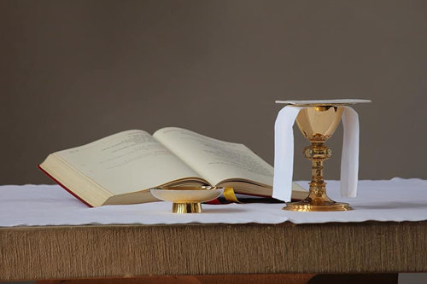
Your parish name here

God’s Generosity Multiplying Our Gifts
What is God calling me to give? Where does God want to send me to find the hungry and the suffering? Who needs to hear me witness about my faith? What would it take for me to really surrender my time, treasure, and talents to His service?

It does not take much to do good, to relieve suffering, or to show love. Consider the example of St. Teresa of Calcutta. When she began her ministry among the poor, she had nothing. She started her order with no master plan or endowment. Rather, she walked the streets, feeding the hungry, and caring for the sick with whatever resources she could muster. She gave the little she had, and through her generosity and holiness, she touched hearts and changed lives.

One day, she came upon a homeless man dying in the gutter. With the help of some men, she brought him to her home. There she washed him, prepared a small meal for him, and prayed. For three hours she did nothing but sit with him. He looked up at her and said, "My whole life I have been treated like an animal, now I will die like an angel." She could not give him much - just her time and her love - but it meant that, in his final hours on earth, instead of dying in the streets, he could die in the arms of a saint.

In the Gospels, Jesus never turns away those in need. Whether they have a question, whether they need healing or whether they are hungry, He gives them what He has, and it never fails to satisfy. The Gospel story about the multiplication of the loaves and fish is a case in point. The five barley loaves and two fish would not have been enough to feed the apostles, never mind a throng of five thousand. Yet Jesus refused to keep the food to Himself. Rather He took it, blessed it, and gave it away. That small act of generosity was enough to satisfy a hungry mass of people with plenty left over.

It is a spiritual law that God uses those who have the least ability to do His work. We often say, "If you want to get something done, ask a busy person." Well, when God wants to get something done, He asks a poor person. By choosing those who are weak, deprived and even sinful, our Heavenly Father makes it clear that it is He who is at work. Otherwise, we might chalk the good deeds up to the cleverness or resourcefulness of those who do them rather than the God who makes all things possible.

God wants to do great things in our families, parishes, and communities. He wants to feed the hungry, He wants to console the suffering, and He wants to change hardened hearts. But He needs us to help Him. He needs us to give even when we think we have too little, to work even when we feel exhausted, and to open our mouths even when we think we have nothing to say. We need to take risks as St. Teresa of Calcutta did by ministering to those dying on the streets and as the boy in the Gospel did who gave his basket of food to Jesus. When we do that, when we step outside our comfort zone in faith, God will take care of the rest.
Dear Jesus,
Help us to spread your fragrance wherever we go. Flood our souls with your Spirit and Life.
Penetrate and possess our whole being so utterly that our lives may only be a radiance of yours.
Shine through us and be so in us
That every soul we come in contact with may feel your presence in our souls.
Let them look up, and see no longer us but you, Jesus.
Stay with us and then we shall begin to shine as you shine,
So, to shine as to be a light to others. The light, 0 Jesus, will be all from you; none of it will be ours.
It will be you, shining on others through us.
Let us thus praise you in the way you love best by shining on those around us.
Let us preach you without preaching, not by words but by example,
By the catching force,
The sympathetic influence of what we do,
The evident fullness of the love our hearts bear for you.
Amen.
By St. John Henry Newman

PARISH NAME HERE God’s Generosity Multiplying Our Gifts Issue 1

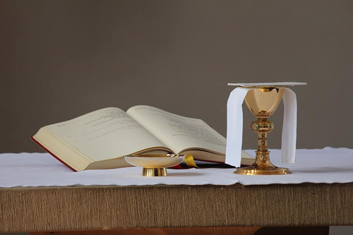
Your parish name here

How Much Should I Give?
You may say “I understand the need to be generous and give to God and his Church. But how much should I give?”

We have all heard the word “tithing.” But what does it mean? The word tithe literally means “tenth.” A tithe was a rule from the law of Moses requiring 10% of an Israelite’s first fruits be given in offertory. Because God provided the harvest, this first part was returned to Him. It was a reminder that all things we have are His. It is a show of thankfulness for His blessings. It also provided for the Levitical priesthood, festivals, and the needy.

In Genesis, Jacob vowed … “Of everything you give me, I will return a tenth part to you without fail.” (Genesis 28:22)

Read ahead to the New Testament and we learn that throughout Jesus’ teaching on giving, He does not undermine the principle of the tithe but encourages people to practice their giving in meaningful ways.

In Mark we hear the story of the widow and her gift.
“He sat down opposite the treasury and observed how the crowd put money into the treasury. Many rich people put in large sums. A poor widow also came and put in two small coins worth a few cents. Calling his disciples to Himself, He said to them, “Amen, I say to you, this poor widow put in more than all the other contributors to the treasury. For they have all contributed from their surplus wealth, but she, from her poverty, has contributed all she had, her whole livelihood.’” (Mark 12:41–44)

This is a beautiful picture of the widow’s trust in God. What beautiful trust that God will take care of her.

And Christ’s response to the widow’s act of faith demonstrates God’s feelings toward our sacrifice and generosity. It is also interesting to note that Jesus took time to sit and watch people give their offerings. God’s interest in our giving is sincere. He recognizes more than we do how our faith is revealed in our habits of giving.

The widow’s story also reminds us that we should give in proportion to the many blessings – our very lives, the food we eat, the air we breathe, our families, our faith – we have received from God. And through our employment, he provides us with financial means to give. As you consider how much to give, Paul reminds us in Corinthians.
“Consider this: whoever sows sparingly will also reap sparingly, and whoever sows bountifully will also reap bountifully. Each must do as already determined, without sadness or compulsion, for God loves a cheerful giver. Moreover, God is able to make every grace abundant for you, so that in all things, always having all you need, you may have an abundance for every good work.” (2 Corinthians 9:6–8)


But still, you may ask “how much am I expected to give?” Only you can answer that question. And it will come to you after prayer with God. A tithe might be the place to start. Or 10% might strain your budget. God expects us to grow in our faith. Our gifts will grow as our faith grows. Start with an amount that works for your budget and faithfully share that each week or month. Next year, evaluate your giving, and increase your offertory gift if you can. After a few short years, you may be giving 10% or more.
This Photo by Unknown Author is licensed under CC BY-NC

How much? Only you can answer this after you prayerfully consider your family’s financial situation. With God’s guidance you will make a decision appropriate for you and your family. As our blessings – i.e., Income – increase, so should our giving.
"Give, and it will be given to you. A good measure, pressed down, shaken together and running over, will be poured into your lap. For with the measure you use, it will be measured to you."
Luke 6:38



PARISH NAME HERE How Much Should I Give? Issue 2

Your parish name here

Benefits of Online Giving
What is online giving?
What are the benefits of online giving? For me? For my parish?
How do I do this? On my phone or tablet?
Should I put my offertory gift in the basket at Mass? Oops, I forgot my envelope.


Online giving is the act of making a gift online for our parish. It can be done by accessing a website from your phone, your tablet or your home computer. Like buying online, you enter your credit card information. Or if you prefer, you can enter your bank account information with, often, less expensive fees for the parish. When you complete the form and submit it, your gift is transferred directly to the parish’s bank account. You will have the option of setting it up to happen regularly – weekly, monthly, or annually.

Benefits for our parish – Online giving offers numerous benefits for our parish.
- Streamlines the donation process, reducing administrative work and processing time.
- Reduces administrative costs to record check, deposit check and less worry about cash handling procedures.
- More secure since there is less access to loose cash and temptation for theft.
- Your gift goes directly from your bank account to the parish account.
- Your gift helps create a steady stream of income for our parish.


Benefits for Donors
- Convenient and accessible anytime.
- You can use a debit card, credit card or directly from your bank account.
- Set it up once and you are done. (If your situation changes, your donation can be evaluated and changed anytime you wish.)
- At Mass, no need to worry if you forget your envelope or your checkbook – no worries, your gift is being electronically transferred.
- “Peace of mind” – “You know that every week or month (your choice) your gift will be delivered into the parish bank account. You can smile as the offertory basket passes by, and smile when you are on vacation knowing your local parish is still benefiting from your gift. Every month, you will be making a real and lasting difference – one gift at a time.

Will I be the only person who gives online?
- Online giving is growing in popularity.
- One parishioner worked months to convince her parish to set up online giving. That is the only way she wants to pay bills.
- We recently learned of a parish that receives up to 75% of their contributions online. Only about 25% of gifts are dropped in the offertory basket. The parish “money counters” are spending less and less time counting.

All this is good, but “I think it is important that my family/fellow parishioners see me put an envelope in the basket at Mass.” Easy solution would be to put a note in your envelope with a note saying, “I gave online.”

Here is the website to give online to our parish [enter link to online giving portal] or scan this code. Check our parish website for more details.
Enter QR code

PARISH NAME HERE Benefits of Online giving Issue 3

Increased Offertory Brochure
(FRONT SIDE)

Increased Offertory Brochure
(BACK SIDE)

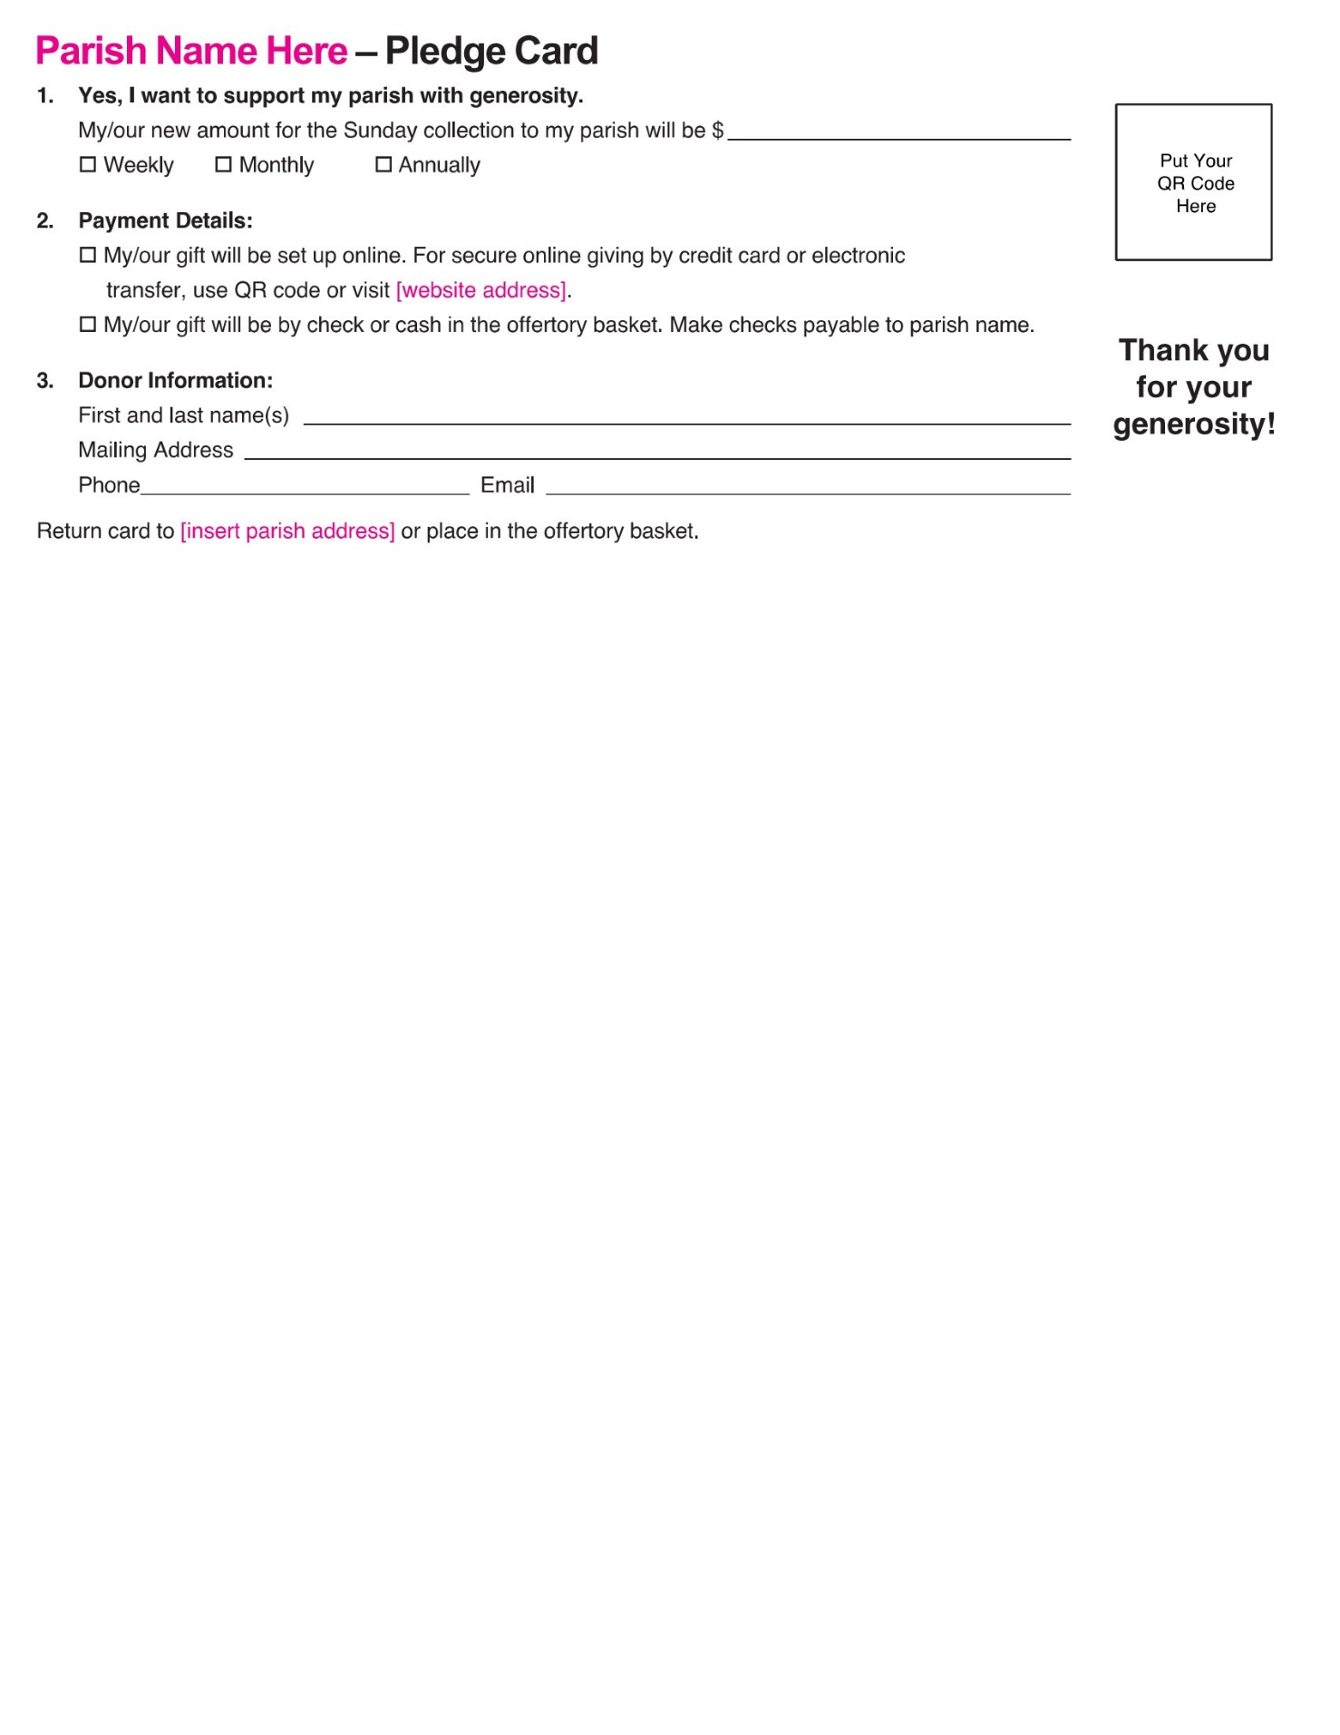
Pledge Card (FRONT SIDE)
Pledge card (BACK SIDE)
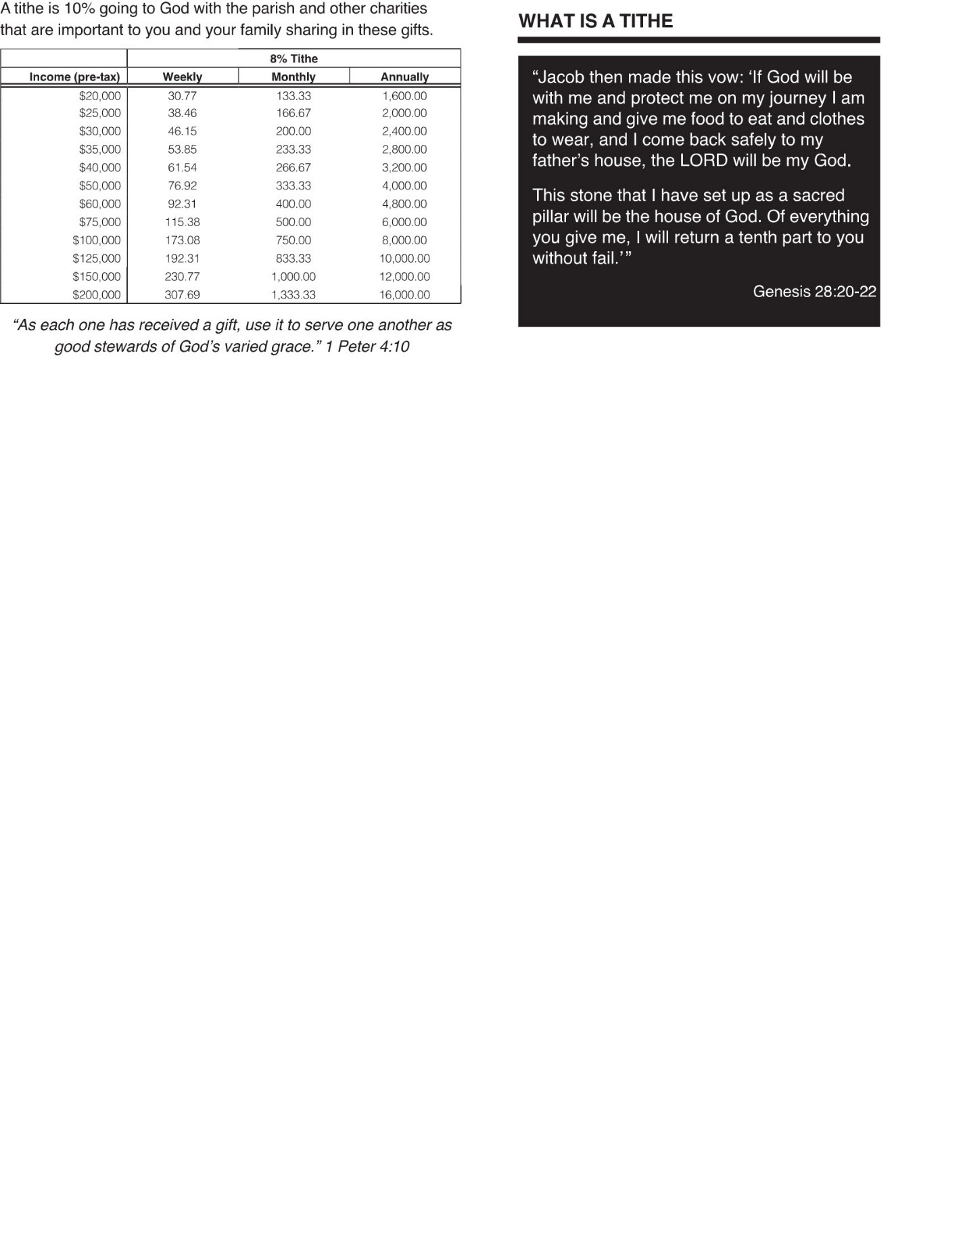

Increased Offertory Calling Script
YOU: Good morning/afternoon/evening, [Name of who you are talking to]. This is [Your Name] from [Add Your Parish Name]. How are you doing today?

MEMBER: (RESPONSE)
__________________________________________________________________________________________________________________________________________________________________________________________________________________________________________
YOU: [I'm glad or sad] to hear that. By the way, before we proceed, I wanted to let you know that if you or anyone you know is facing any challenges such as illness, loss of a loved one, or struggling with addiction, please let me know. Our church community believes in the power of prayer, and we can add their names to our prayer list.

MEMBER:
__________________________________________________________________________________________________________________________________________________________________________________________________________________________________________
YOU: You're most welcome. My call today is to kindly remind you about the Increased Offertory Commitment Card that was recently mailed to your home. We greatly value your ongoing support and commitment to the mission of [Add Your Parish Name].

MEMBER:
__________________________________________________________________________________________________________________________________________________________________________________________________________________________________________
YOU: [That's wonderful to hear]. Your participation in the Increased Offertory program helps us continue the various ministries, outreach programs, and services we provide to our parishioners and the wider community. We encourage you to prayerfully consider increasing your contribution if you are able.

MEMBER:
__________________________________________________________________________________________________________________________________________________________________________________________________________________________________________

YOU: Thank you for your openness. To complete the process, you can simply mail back the commitment card to our parish office at [Add Your Address Here] or drop it in the collection basket during Mass. Your timely response will assist us in planning and ministries for the upcoming year.

MEMBER:
__________________________________________________________________________________________________________________________________________________________________________________________________________________________________________
YOU: Great! We genuinely appreciate your dedication and support. Is there anything else you would like to discuss or any concerns you'd like to share with me?

MEMBER:
__________________________________________________________________________________________________________________________________________________________________________________________________________________________________________
YOU: Alright then. Once again, thank you for your time, [Member's Name]. It was wonderful speaking with you. We look forward to seeing you at Mass and witnessing your continued presence in our parish community.

MEMBER:
__________________________________________________________________________________________________________________________________________________________________________________________________________________________________________

YOU: I pray you have a blessed day.

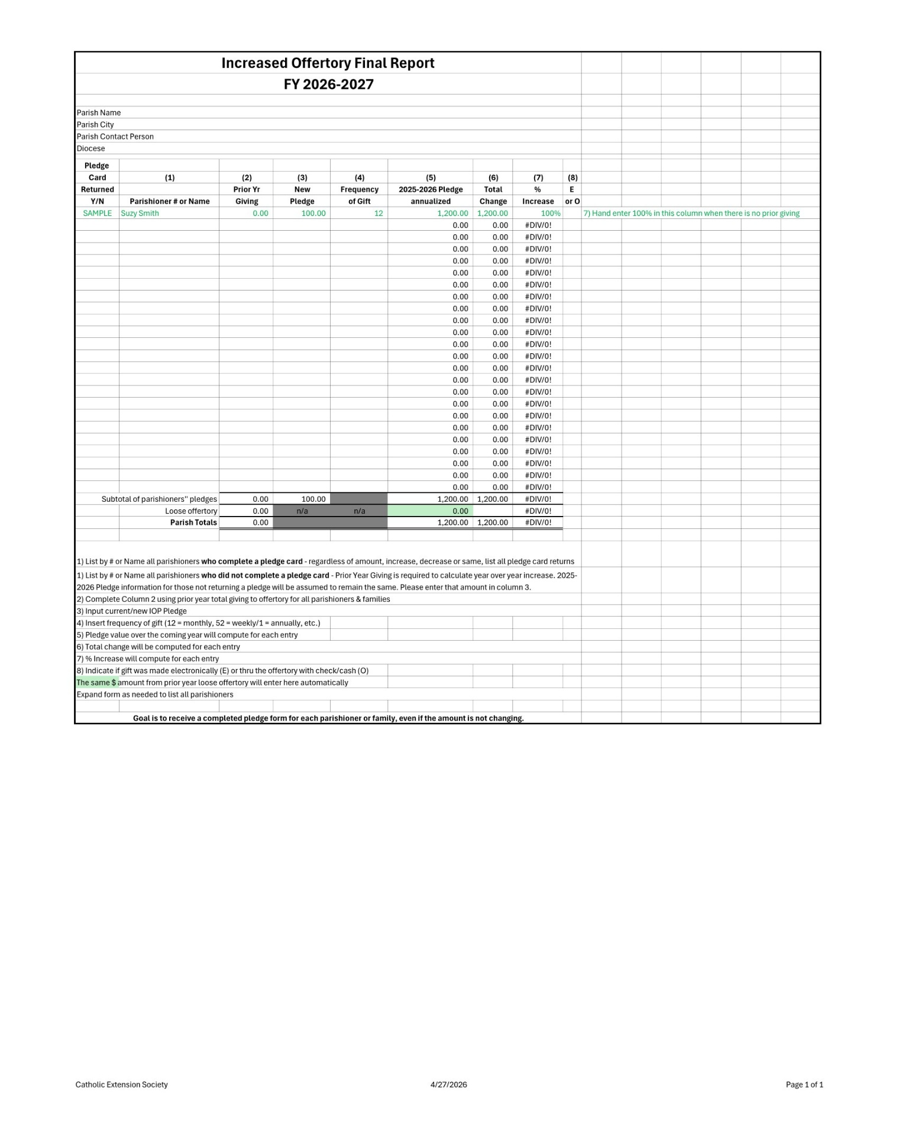
Increased Offertory Report Final Report

Notes:
___________________________________________________________________________________________________________________________________________________________________________________________________________________________________________________________________________________________________________________________________________________________________________________________________________________________________________________________________________________________________________________________________________________________________________________________________________________________________________________________________________________________________________________________________________________________________________________________________________________________________________________________________________________________________________________________________________________________________________________________________________________________________________________________________________________________________________________________________________
George Shadroui
Office of Development
Catholic Diocese of Memphis
George.shadroui@cc.cdom.org
901-373-1226
5825 Shelby Oaks Drive
Memphis, TN 38134

